Task 5

- Add to your Frequency domain menu the following features:
- Computing DCT for a given input, display the result and the user can choose the first m coefficients to be saved in txt file.
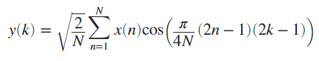
- Add to your framework a menu named Time Domain that includes the following features:
- Sharpening: Compute and display y (n) which represents
First Derivative of input signal
Y(n) = x(n)-x(n-1)
Second derivative of input signal
Y(n)= x(n+1)-2x(n)+x(n-1)
- Delaying or advancing a signal by k steps.
- Folding a signal.
- Delaying or advancing a folded signal by k steps.

